## 

**GRADE 12 ENGLISH HL**

**LANGUAGE NOTES: Comprehension 22 February 2025**

**Notes Compiled by Ms J.Govender**

**Comprehension**

* Read passage carefully.
* Read questions.
* Read Text B before reading Text A for the second time.
* Read Text A.
* Answer Questions

|  |  |  |  |
| --- | --- | --- | --- |
| Q | Key word in question | Generic answers | Mark allocation |
| 1.1 + 1.2 | Explain  /**State in your own words**/  explain the significance.  Account for | Give meaning/Rewrite in your **own words** to show the meaning.  Short answer.  DO NOT LIFT.  Do not spend too much time. | One fact = 2 marks.  If there are more than one obvious fact – write **two**. |
| **Significance** | Importance. **Why does the writer use this word** in this **context** or make this claim at this specific point? | One fact = 2 marks/ 1 Fact per mark |
|  | Account for the **writer’s feelings** in a par /the following… | Make sure that you read the whole par. Sometimes the writer expresses **different feelings**. Note the **conflicting** view. Look for words like **Yet/ However**  Name feeling and explain why the writer feels this. |  |
| 1.3 + 1.4/  1.5 | **Convey** | What does the writer express? What is she **trying to say?** |  |
| Discuss the **point the writer is making….** | **Watch out for a specific word** and don’t lift it. |  |
| **Effect of…**  **Single line par** | Writer brings **topic/main idea into focus.**  **It highlights/emphasises the main idea/an idea.**  **Single line indicates a change in thought**. | 1 **Generic answer**  2 Reference to **topic/main idea/change**. |
| **Rhetorical question** | (Do not explain what a rhetorical question is.)  Makes **reader think/reflect/consider, engages reader**. | 1. **Make reference to the text.** |
| **Quote** | Quote only the **word, phrase or short sentence**…  Consecutive words (words that follow directly after each other) | **Include “ ”** |
| **Implication** | What does this **imply**? What is the **underlying meaning** of the word, phrase, **punctuation mark, exclamation, etc..** |  |
| **Inverted commas** | Words from **another language. Slang/Sarcasm/Irony** – other words the writer wants us to know that it **is not true.** E.g. He was not selected to represent South Africa because he was the “wrong” colour. |  |
| **Intention** | **Intention**  To **inform, educate, entertain, promote, advertise, ridicule, criticise**.  To stir romantic feelings and to entertain.  To praise the work of the Creator.  To **capture attention** and inform.  To **give general information** about a specific topic. **Educate**.  To **socialize** and to communicate informally.  To **invite and attract**  To **protest**  To **persuade** prospective travellers, buyers, participants, etc. (inform about a product or service) To promote/advertise  To **amuse**  To **entertain** young readers, to teach a moral lesson.  To **report** on economic matters, the weather, politics… |  |
|  | **Statistics** | **Statistics** allow **writers** to support **their** arguments with convincing evidence. They also enable **writers** to draw conclusions and argue specific sides of issues without sounding speculative or vague. **Effect on reader**. **Statistics** refer **to factual, numerical evidence** within a Language Analysis piece and are generally **convincin**g for two reasons. Firstly, they highlight the **logical importance** of the issue and **provide evidence** for the writer's contention. **Statistics-** provide a type of evidence that is difficult to refute. To-**manipulate/shock/add validity/emotional response.** |  |
| 1.5 – 1.8/9 | Comment on the effects of the **diction** | Emotive – Plays on our emotions  Diction -Effect is what the **word or phrase or punctuation mark achieves** – does it **shock** the reader? Make the reader **pay attention**? **Emphasise**?  Take note if question refers to diction at a specific point in the text: Comment on the use of the word **here**(line/para)  Write down the word/ phrase  **Superlatives** – greatest, fastest, tallest …  **Rhyming words/Jargon/ Figurative Language …simile/ metaphors…Colloquial/ Slang/ Pronouns He/She** | 1 Example of diction – quote word or phrase  2 Effect that the word or phrase or punctuation mark achieves.  3 How do YOU feel about this effect? |
|  | What does **writer suggest**? | **Implication**. |  |
|  | ...**in context** of the paragraph/  passage. | **NOT your own opinion** but actually compared to/in the light of what **the writer** says. |  |
|  | Writer’s **tone/attitude** | **The writer’s attitude/tone towards his listener and subject (“tone of voice”) e.g. loving, sad, aggressive/hostile, serious, despairing, positive/enthusiastic/excited, sincere, outraged, superior, ironical, pessimistic, critical/disapproving/apprehensive, disgusted, enthusiastic, optimistic, friendly/pleasant/polite, humorous, gentle/tender, joyful/elated, loving/affectionate, appreciative/admiring/laudatory, hopeful, conversational, determined, persuasive/enticing, arrogant, accusing, mocking, informative/explanatory.** . **NOT NEGATIVE/POSITIVE** | 1 What is the writer’s tone/attitude?  2 Why is this so?  Proof of this.  3 Your feeling about this tone/attitude (with reference to rest of text.) |
|  | **Character’s attitude** | **Writer’s feeling**. **Difference in attitude**: Make very sure to mention **both attitudes** and show that they are different. Then give evidence of why you say that. **NOT NEGATIVE/POSITIVE** |  |
|  | Critically discuss the **atmosphere** in paragraph | **Mood that is created**. **Fear, anxiety, excitement, anticipation, tension, sorrow, admiration** |  |
|  | Critically discuss whether **paragraph/**  **Sentence/**  **compares texts** | **Compare two ideas**: meaning of first, meaning of second.  Do they **correspond with each other or contradict each other?**  Give a very **brief personal observation** – based on text – about the extent/significance of the support/contradiction. | Yes/No (No mark, but very important.  1 Main idea of two aspects that have to be compared.  2Proof/examples/diction/phrases from second aspect.  3 Critical observation |
|  | Is **final paragraph** suitable? | A final paragraph gives the **main ideas of an argument** and refers to the thesis statement again.  It could refer to the **opposite side of the argument**.  It could contain **advice**.  It is a **summary**.  **Repeats phrases**/terminology from the rest of the passage.  The **reader is drawn** into the argument through the use of **first-person pronoun.**  The writer generalizes/globalizes. | Yes/No (No mark, but very important.  1 Generic reference to structure/ reason for a final par.  2 Brief summary of content of this final par.  3 How is it suitable or not? |
|  | **Suitability of title** | Implication of **DIFFERENT parts** of title.  **Main idea**/message of text. |  |
|  | **Text -Subjective/**  **Objective?** | **Objective**: Usually f**ormal**, **no bias**, **no prejudice**, **tone** would be **informative/explanatory/serious**, carefully selected **vocabulary**, formal grammar, **clear, logical**, academic explanation, sophisticated diction, formal register and **economic/legal/technical/medical/etc jargon**.(words used by a profession/group that are difficult for others to understand)  **Subjective**: **Biase**d, **prejudice,** **emotive** language, the use of **colloquialisms**, **slang and direct speech**, use of **clichéd, melodramatic(exaggerated) and sentimental language, outraged, superior**, ironical, despairing, pessimistic, critical, **disgusted, disapproving tone/attitude, rhetorical questions.** |  |
| 1.12 | **Text A & B** | **Will never only be contextual.**  Does **Text B support paragraph/title/argument/message**/etc. in Text A?  Which text would have a **bigger impact** on the reader? Why?  Compare a description of something in Text A and something in Text B.  **Which text is more effective** in doing something.  November 2018: To what extent does Text B support the title and par 1 of Text A? Here learners **HAD** to discuss **content.** |  |
|  | **Language style** | Carefully selected **vocabulary**  Varied **sentence structure**  Formal grammar  Sophisticated diction, formal register and economic/ legal/ technical/ medical/etc **jargon.**  **Objective, unbiased**  Simple but imaginative word choice, simple sentences and frequent use of onomatopoeia.  The use of **colloquialisms**, **slang and direct** **speech**.  Word play combined with question-answer format  **Clear, logical**, academic explanation  The use of **emotive** and negatively charged words to describe a tragic incident.  **Poetic rhythm, rhyme** and abundant use of figurative language, assonance and alliteration.  Use of **vivid imagery and emotive** adjectives to describe geographical/ historical/architectural/etc. features.  Combination of simple rhyme, based on a **shocking** i**mage**, with words that have strong connotations.  **Enumeration (list**) of culinary/décor/teaching/sport/etc specialities, using descriptive and figurative language  Use of clichéd, melodramatic and sentimental language  **Politically Correct Words**: Housewife – Home Executive  **Informal**  Slang – (e.g. wanna, gonna)  **Conversational style**/use of **personal pronouns** crates a bond of confidence between the writer and the reader/ involves the reader in the passage.  **Emotive language**  **Biased / prejudiced**  **Sensational**  Connotation  **Figures of speech**  The writer uses metaphorical expressions/hyperbole such as….to highlight the….  **Exclamations !!!!**  **Ellipses ….** |  |

**QUESTIONS**

**NOVEMBER 2015 PAPER 1**

**QUESTIONS AND ANWERS – COMPREHENSION November 2019 P1**

1.1 Account for the repetition of 'and' in the opening sentence of the passage (lines 1–2). (2)

***We've all seen the toys and the clothes and the movies ... and the adverts for those toys and clothes and movies. Pink versus blue; passive versus aggressive; sedentary versus active; pretty versus smart. Girls versus boys.***

1.2 Suggest why the writer uses the phrase, 'breath-taking act of psychological vandalism against our children' (line 13). (2)

1.3 Discuss the effectiveness of paragraph 3 in the context of the passage. (3)

***How has the influence of the media grown? How has parenting become harder?***

1.4 Why does the writer invite the reader to 'time-travel' (line 17) with him/her? (2)

***Time-travel with me for a moment. Let's go back to an era when media played a minimal role in people's lives. How about the year 1900? The telephone had been invented but was not yet commonplace in the average home. Television would not arrive for decades. No Internet, smartphones, computer games, blogging or social media existed anywhere but in the creative imaginations of inventors, scientists and authors. What kind of media did exist?***

1.6 Refer to paragraph 6.

***Fast-forward 100 years to the year 2000 and beyond. What communication technologies can currently be found in the average home? Does anyone think this is not the single biggest game-changer in the lives of adults and especially today's children, who are spending all of their formative years in a digital world, saturated by every manner of screen and dead-tree advertisement our capitalistic society can shove in front of their faces? The media are the greatest source of information, and perhaps the greatest untamed beast, the world has ever known.***

Comment on the effectiveness of the diction used in discussing the media. (3)

1.8 Choose the correct response from the options provided below.

Refer to paragraph 10 ('Are the media ... above its reach'). The writer's tone is ...

***Are the media going away? No. Should it? Absolutely not. Media literacy is therefore very important, because the media are pervasive in our culture and affect everyone. No one, except a cave-dweller, remains above its reach.***

A aggressive

B assertive

C hostile

D offensive

1.9 Is paragraph 12 an effective conclusion to the text? Substantiate your view. (2)

***So let's hear it for our youngest generation of parents, who make a go of it in the Internet Age – self-high-fives***

**1.9 YES**

**The writer acknowledges that parents have an onerous task in ensuring that the power of the 'third parent in the room' (the media) is lessened. They need to be encouraged to take up the challenge of responsible parenting with gusto. The expressions 'let's hear it' and 'self-high-fives' suggest approval and self-motivation. The light-hearted conclusion rounds off a serious topic on a positive note.**

# QUESTIONS: TEXT B

[

Source

:

[www.lego.co](http://www.lego.com/)

[m](http://www.lego.com/)

[]](http://www.lego.com/)

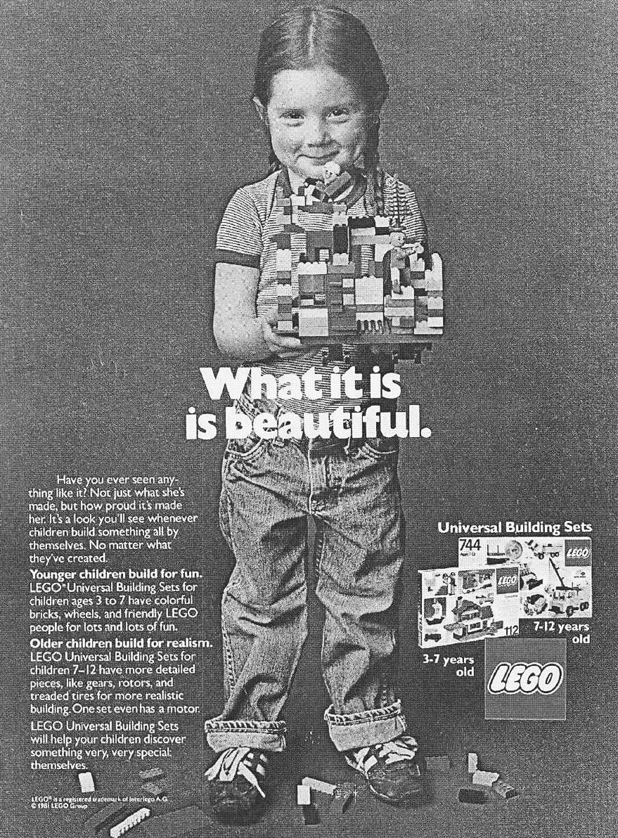

1.11 Critically comment on the manner in which the girl in the advertisement

is presented. (3)

# QUESTION: TEXTS A AND B

1.12 Does the message of TEXT B support the writer's view as expressed in (4)

paragraph 2 of TEXT A? Justify your response.

***It's so insanely formulaic1 and a lot of adults are laughing all the way to the bank at the expense of our children's self-definition. The strategy is simple: convince children of both genders that they are very different from each other. They need different products with different colours and different labels, and they will naturally want only what they've been told is 'for' them and what has been spoon-fed to them since birth. Parents will then dole out double the money buying separate products for their sons and daughters, ensuring that the retailers and marketers double their profits and cash in on the stereotyped messaging. And why wouldn't they? It's brilliant. It's lucrative. It's also a breath-taking act of psychological vandalism against our children. The media shape perception and perception become reality.***

**November 2023**

**1.11. Refer to both TEXT A AND TEXT B. Critically discuss the extent to which TEXT B supports the subheading, From audiobooks to.. understand the world and paragraph 4 of TEXT A.**

**LISTENING INSTEAD OF READING IS NOT CHEATING**

***From audiobooks to podcasts and voice notes, there’s a steady generational shift in the way we understand the world***.

***4.Reading is still very far from dead. Lockdown rekindled the love of curling up with a good novel, to publishers’ delight, with more than a third of people claiming to be reading more to fill their days. But the audio book market, while still small, also notched up its seventh year of double-digit growth in the 2021 pandemic year. Millennials in particular seem to be all ears; Katie Vanneck-Smith, the former Wall Street Journal President, admitted recently that when its members (who are mostly under 39 years old) were asked what they wanted to read, the consensus was, ‘Actually, I Iisten, I don’t read. ‘But their parents do so too: all the overloaded, frantically multitasking mid-lifers trying to keep up with whatever zeitgeist 2 they are afraid of missing out on in an information-saturated world, while going for a run or cooking dinner***

**TEXT B**

